**Chapter 11 exercise – using Event Viewer to monitor and manage logs**

In this exercise, you will learn how to do the following:

Set up centralized monitoring

Filter Event Viewer logs

Change the default logs location

## Setting up centralized monitoring

To set up centralized monitoring in Windows Server 2019, complete the following steps:

1. On DC1*,* open the **Command Prompt** with elevated admin rights, enter winrm quickconfig, and then press *Enter*.
2. In Server Manager, click Tools and then click Active Directory Users and Computers..
3. In the domain, doubleclick the Builtin container.
4. Open the administrators group and add SVR1.
5. On **SVR1***,* open **Command Prompt** with elevated admin rights, enter wecutil qc, and then press *Enter*.
6. Press **Y** (for yes) when prompted to do so.
7. From the **Command Prompt** window, enter eventvwr.exe to open **Event Viewer**.
8. Right-click on **Subscriptions** and select **Create Subscription...**.
9. Enter the **Subscription name** and its **Description**.
10. Select **Forwarded Events** as **Destination log***.*
11. Select **DC1** by clicking on the **Select Computers...** button, as shown in *Figure 11.20,* and then click on **OK**:

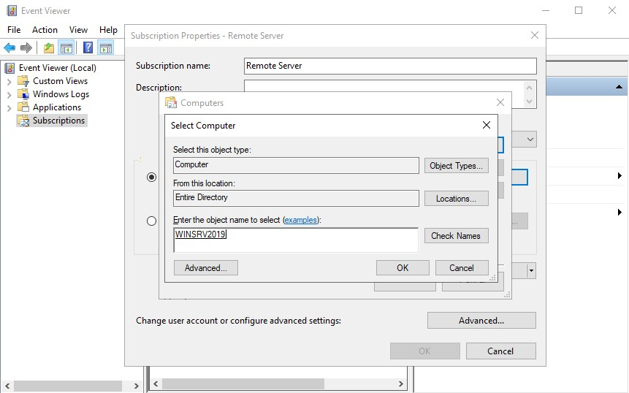

Figure 11.20: Adding Remote Server in order to collect events

1. In the **Subscription Properties** window, click on the **Select Events...** button, and select **Edit**.
2. In the **Query Filter** window, set the event logs filtering criteria that you want to collect and click on **OK**.
3. Click on the **Advanced...** button to make sure that the machine account is the chosen option, and then click on **OK**.
4. Click on **OK** to close the **Subscription Properties** window.

Now that we have set up centralized monitoring, let's filter Event Viewer logs.

## Filtering Event Viewer logs

To filter the Event Viewer logs in Windows Server 2019, complete the following steps:

1. Press the Windows key + *R*, enter eventvwr.msc, and then press *Enter*.
2. Expand **Windows Logs** and select the log type that you want to filter.
3. In the **Actions** pane, click on **Filter Current Log...**, as shown in *Figure 11.21*:

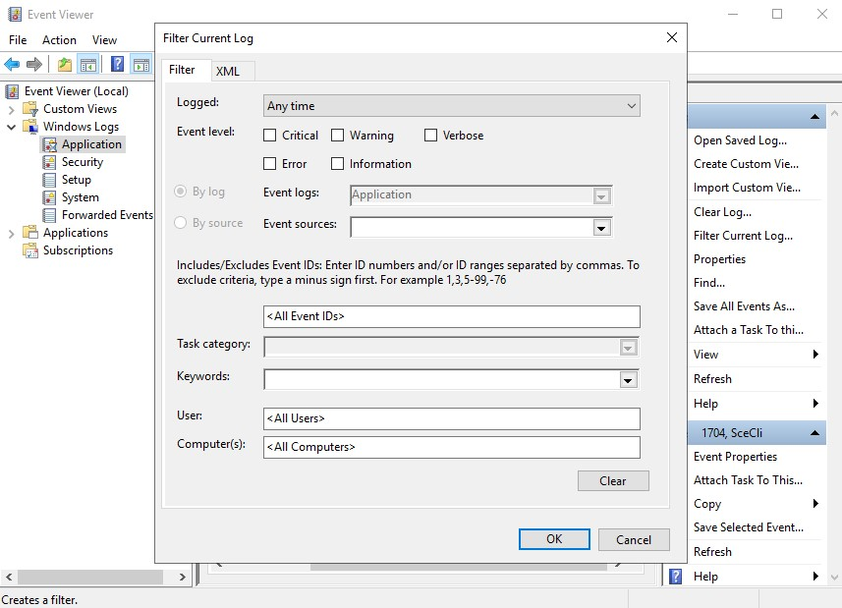

Figure 11.21: Filtering Event Viewer logs

1. In the **Filter Current Log** window, set the filtering criteria to get the desired results.
2. Click on **OK** to close the **Filter Current Log** window.